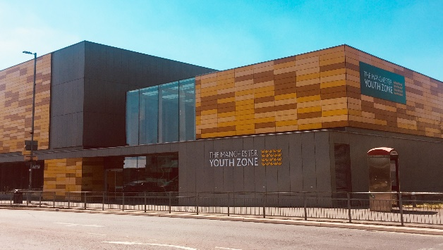
CATERING ASSISTANT
Harpurhey, Manchester
Salary £12ph
12 hours per week – days and evenings (to be agreed at interview)
Reports to: Catering Manager

Why work for Manchester Youth Zone
- Annual leave entitlement of 33 days (pro-rata)
- We are committed to training and developing our staff, that will include a full induction and access to internal and external training opportunities
- We care about your wellbeing – Access to our EAP, an extra holiday day for your birthday, and onsite gym and sports facilities
- 5% pension contribution
- You will be part of our mission to positively impact the lives of young people in North Manchester

Manchester youth zone is committed to safeguarding and promoting the welfare of children, young people and vulnerable groups. This post is subject to a safer recruitment process, including the disclosure of criminal records through an enhanced DBS and completion of appropriate vetting checks. We promote safer working practice across our Manchester youth zone and all successful employees and volunteers will be expected to share this commitment.
The Manchester Youth Zone first opened to young people in 2012 as an independent charity. Located in Harpurhey enables the Manchester Youth Zone to reach those young people who need “Somewhere to go, something to do and someone to talk”.
We work with young people aged 8-19 and up to 25 for those with additional needs offering provision during the day (including weekends) for targeted young people and each evening for universal provision. The Manchester Youth Zone has an excellent reputation in a number of areas including safeguarding, working with young people who are “at risk” of criminal exploitation, mentoring and employment skills. We have invested strongly in partnership working, becoming a community asset responding to the needs of young people and the local community of North Manchester. Please visit our website to learn more about the work we do!

Job Description
We’re looking for a Catering Assistant to support our busy kitchen area, where over 100 young people are fed each day. With over 60% of our members on free school meals, our catering provision is an integral part of what we offer children and young people, and the successful applicant would be responsible for maintaining a high standard of food, effective communication with young people, and cleanliness of the kitchen.
Key Duties
- To be responsible for cooking and serving hot and cold meals to young people,
- Work with the catering supervisor to create a cyclical menu plan which is nutritious and cost effective
- To maintain a high standard of cleanliness in the kitchen and dining area, reporting any defective equipment or hazards to Facilities Manager
- To follow food hygiene and allergen procedures at all times
- To operate and maintain different cooking appliances
- Replenishing catering supplies, and ordering of new stock (training will be provided)
- Completing daily records including temperatures, allergen logs and delivery logs
- To be responsible for monthly deep cleaning, following the cleaning schedule
- Completing other tasks as allocated by your line manager
- Working with the wider team, including taking part in daily briefing sessions with the youth work team so that you are aware of any concerns for young people that you will communicate with during your shift
- Undertake regular training and development relevant to the role
- Actively address any bullying, harassment, or discrimination, promoting cohesion, inclusion, and positive relationships
- To understand and adhere to MYZ policies and procedures at all times with particular emphasis on equal opportunities, positive behaviour management, health and safety and safeguarding.
- Promote and safeguard the welfare of children and young people at all times, managing any safeguarding issues should they arise (training provided)
- To be an active member of the team and operate in line with the Charity’s expectations, values and principles. Work a flexible pattern including evenings and weekends in line with the role/team requirements
- Promote a positive image of MYZ through professionalism and good conduct with all our stakeholders and the public

PERSON SPECIFICATION
 | Essential | Desirable | Identified by
Skills & Attributes
Ability to communicate clearly with a wide range of people and follow instructions and recipes | Y |  | CV
Ability to manage time effectively and prioritise work | Y |  | Interview
Be flexible to changing demands of the post | Y |  | Interview
Initiative and the ability to work without supervision | Y |  | Interview
Ability to work in a team and get on well with others | Y
Experience
Working in a catering role within a public building/organisation | Y |  | CV/Interview
Working to allergen, food hygiene and health & safety procedures |  | Y | Interview
Experience of working with and communicating with children, young people and vulnerable young adults, demonstrating empathy and supportive approach |  | Y | CV/Interview
Placing catering orders, ensuring minimal wastage, and ensuring maximum cost efficiency |  | Y | CV/Interview
Knowledge & Understanding
Food Hygiene Level 2 | Y* |  | CV/Interview
NVQ Level 2 Food Preparation or Professional Cookery |  | Y** | CV
Ability to understand, follow and implement policies and procedures | Y |  | Interview
Additional attributes
Organised and efficient | Y |  | CV/Interview
Excellent attention to detail | Y |  | CV
Punctual and reliable | Y |  | References
Calm under pressure | Y |  | CV/Interview
Commitment to personal & professional development |  | Y | Interview
Commitment to supporting the aims of the charity | Y |  | Interview
*training will be provided **potential opportunity to complete qualification in future

